Ideation Phase

Define the Problem Statements

|  |  |
| --- | --- |
| Date | 29 APRIL 2023 |
| Team ID | NM2023TMID20356 |
| Project Name | The Future of Work: Data Analysis of Glassdoor Jobs |
| Maximum Marks | 4 Marks |

**The Future of Work: Data Analysis of Glassdoor Jobs:**

1. **PROBLEM STATEMENT – 1:**

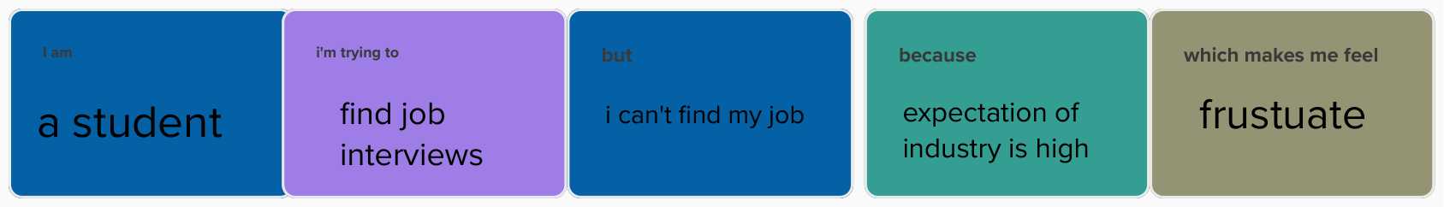

1. **PROBLEM STATEMENT – 2:**

